**Student Expectations and Class Requirements**

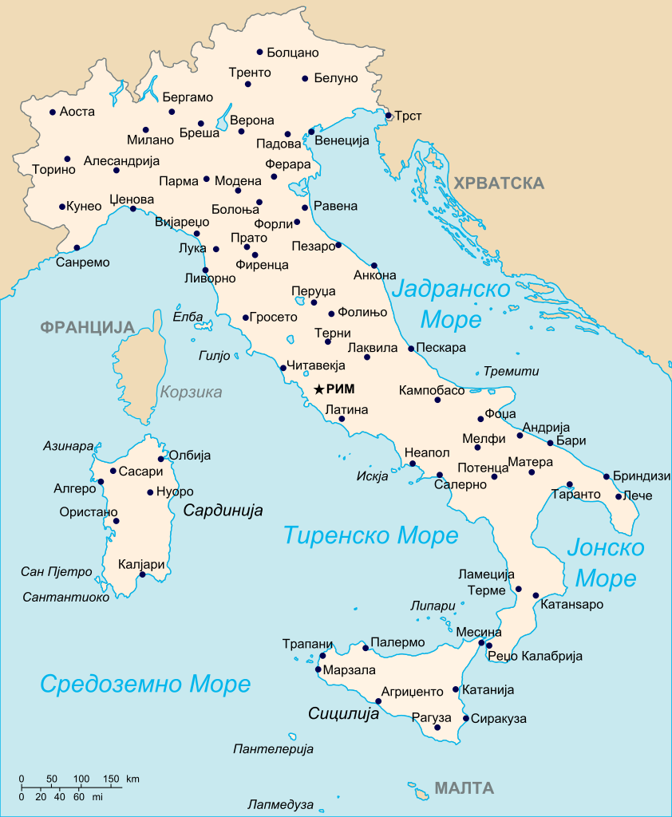

***C:\Users\David\AppData\Local\Microsoft\Windows\Temporary Internet Files\Content.IE5\5F5O39LS\MC900129202[1].wmfItalian CP B2/World Languages***



*Ms. Adorno / RM 218*

**2021-2022**

**Course Description/Course Goals:**

Italian CP B2 is the last course of a three-year sequence for high school Foreign Language Study in New York State. The topics are spiraled and sequenced throughout the year so that students review and build on previous learning. Students who complete the course successfully will develop language proficiencies in the four main components of language learning: listening, speaking, reading, and writing with an emphasis on the 3 modes of communication: Interpretive, Interpersonal, and Presentational. Culture, which is another main goal of language learning, is incorporated into the lessons so that students gain an appreciation of the Italian culture. The overall goal is for the student to communicate needs and knowledge in Italian at a more intense level. The course ends with a district-wide assessment, the 4 + 1 OHM BOCES LOTE exam.

**Required Supplies:** *You must bring the following items to class on a daily basis*.

* 1 ½ inch binder with loose leaf paper or a two-three subject notebook. (please do not share with any other class)
* Pens, erasable pens, pencils, highlighter
* Italian/English dictionary (*www.wordreference.com*)
* 2 Folders (one for homework and one for class work/handouts)
* Index cards

**Grading:**

* **You will be graded on a variety of assignments including:** Classwork, homework, group work, quizzes, tests, writing assignments, quarterly projects and tests, presentations, portfolio, Journals, and participation.
* **Participation** in class activities is required in order to succeed in learning the language.
* 30% Classwork Assignments, 30% Projects, 20% Tests and Quizzes, 10% Professionalism (attendance, participation & behavior) 10% Homework, Portfolio & Journal
* Extra credit work will be assigned accordingly if you would like to increase your grade.

**Assignments:**

* All assignments will have specific due dates and will be posted on Teams. The work is to be completed when due.
* Homework is given every night and it is expected it to be done before the next class meeting. If no homework is assigned then you are expected to review what was learned in class.
* Throughout the year, you will be assigned many different assignments such as: Projects, presentations, group work, etc. All assignments will have certain guidelines and due dates to be followed. You will always be given enough time to complete all assignments.

(**Hint**: *do not wait for the last minute to complete assignments!*)

**If you have any concerns or need extra help, I am available after school on Wednesdays or during 8th period.**

**Make up Work:**

* If you are absent from class, you are to make up the work that you missed. This includes class work and homework. The makeup work will be due the day after you return. If you are absent on the day of a quiz or test, you may make up the test. You must consult with me to set up an appointment to take the quiz/test.

**Late Work Policy:**

Homework – no credit – zero

Other assignments – minus 10 points each day an assignment is late.

**Microsoft Office 365:**

* If you need to e-mail me about any assignment you can reach me at

[**nadorno@YonkersPublicSchools.org**](mailto:nadorno@YonkersPublicSchools.org)

**Curriculum:** The following themes/topics will be covered throughout the school year with a concentration on the four main components of language learning: listening, speaking, reading, and writing following the NYS standards and the Common Core Standards.

**1st Quarter**

* Identity & Social Relationships
* School Life and Education
* Leisure
* Project - Italian Culture and Heritage Month Project -Mid October – Beginning of November
* Writing Assignments/Current Events

Important Websites & apps

* Microsoft 365
* Word Reference
* Remind *Kahoot
* Quizlet *Nearpod
* Conjuguemos * Voki
* Mindsnacks Italian
* Rai.it *Duolingo
* Repubblica.it
* 1st Quarterly Assessment

**2nd Quarter**

* Family & Social Relationships
* Global Awareness & Community Engagement
* Contemporary Life/Shopping/House and Home
* Project – La lettera dei Desideri/International Education Week
* Writing Assignments/Current Events
* Mid-Term Exam

**3rd Quarter**

* Food & Meal Taking, Science, Technology & The Arts – Health & Wellness, Technology, Media & Social Media, Global Awareness & Community Engagement
* Project – Carnevale/La Favola/Il Progetto della Nutrizione
* 3rd Quarterly Assessment

**4th Quarter**

* Contemporary Life – Travel, Communities & Neighborhood
* Earning a Living
* Environmental Issues & Sustainability
* Final Project – Annuncio del Lavoro
* Writing Assignments/Current Events
* Final Exam (*the above schedule is subject to change)

**Procedures for Students:**

* **Attendance ~ Be on time!** You must be in class before the late bell/music rings otherwise you are late for class. If you are late to class, you must come in with a late pass. You must be in your seat with your supplies out and ready to work after the late bell rings.
* After the late bell rings begin the **Do Now (Fare Adesso) which will be on the smart board.** You will have the first five minutes of class to complete it.

**PROFESSIONALISM**

* Attend to personal needs before coming to class.
* **Be Prepared to Learn!**  You must bring all the required materials to class every day!
* **Participate in all class activities!**
* **Be respectful!** Show respect to everyone and everything in the class. Use polite speech and body language. *Treat others the way you would like to be treated!!* ***Refrain from eating, drinking or chewing gum in the class!! Take off any headgear and refrain from using your cellphone, I pod or mp3 player or any other electronic device!***
* Always follow the **teacher’s directions** immediately!

**Student Expectations and Class Requirements**

***C:\Users\David\AppData\Local\Microsoft\Windows\Temporary Internet Files\Content.IE5\FOXYDKR7\MC900433600[1].wmfC:\Users\David\AppData\Local\Microsoft\Windows\Temporary Internet Files\Content.IE5\5F5O39LS\MC900129202[1].wmfItalian CP B2/World Languages***

Roosevelt High School Early College Studies

*Ms. Adorno / RM 218*

**2021-2022**

Please return to Ms. Adorno by **Wednesday, September 15, 2021**.

I have read and understood the expectations and requirements for Ms. Adorno’s Italian class and have shared them with my parents.

**Student’s Name** ______________________________________ **Period** _______________

**Student’s signature ___________________________________________________**

**Parent’s/Guardian’s signature** ___________________________________________________

Thank you! I look forward to working with you and your child this year!

---------------------------------------------------------------------------------------------------------------

**Dear Parents/Guardians:**

Please fill out the following form and return it to class with your child no later than Wednesday, September 15, 2021. Thank you!

Parent/Guardian’s name ________________________________________________

*Contact numbers:*

Home phone number ___________________________________________

Cellular phone number _________________________________________

Work phone number _________________________________________

E-mail address _______________________________________________

Thank you,

Ms. Adorno

Italian Teacher

Roosevelt High School Early College Studies

(914) 376-8118

[nadorno@YonkersPublicSchools.org](mailto:nadorno@YonkersPublicSchools.org)